COMPUTER NETWORKS

BCSE308P

LAB WORK - 4

NAME: Adhithya Kumar Tummala

REG NO: 24BCE1588

NS-3 INSTALLATION (Version 3.39) in ubuntu:

STEP-1 : Installing ns3.39 version from official ns3 website
Link : https://www.nsnam.org/releases/ns-allinone-3.39.tar.bz2

STEP-2 : Extract the file and save in home

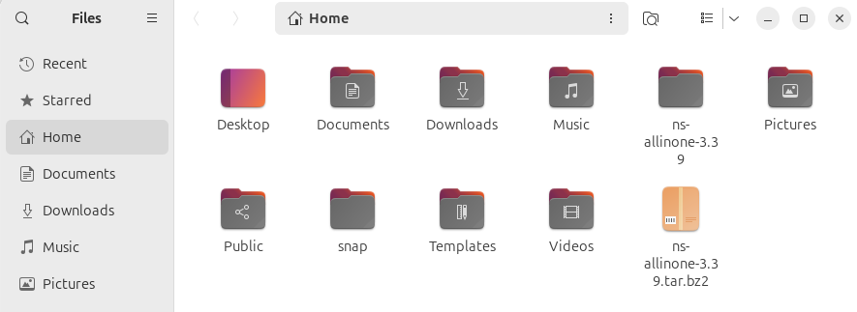
STEP-3 : Navigating to : ns-3allinone-3.39 -> ns-3.39 and then openeing terminal
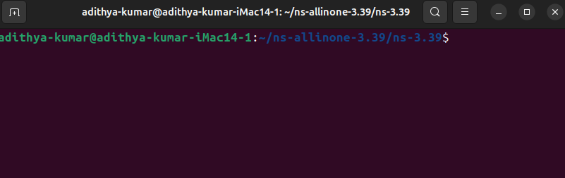

STEP-4 : Enter command ./ns-3 configure
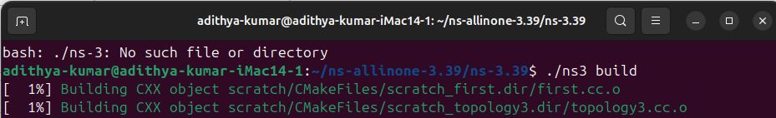
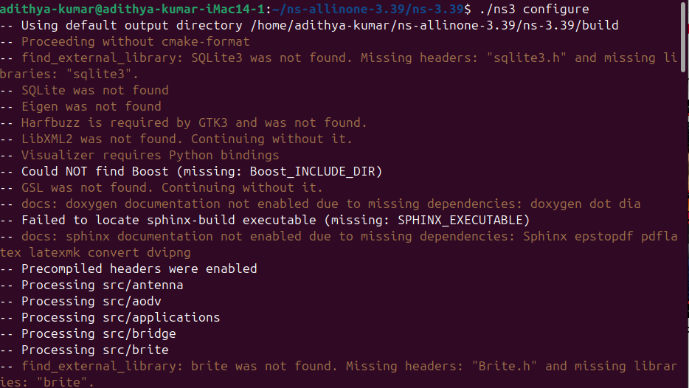
STEP-5 : Enter command ./ns-3 build
Now ns-3 has been installed successfully
Proof:
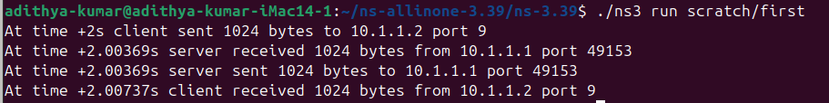

Creating 5 topologies using ns3 and displaying :

1) Star topology:

Creating a file named star.cc and saving the c code in tht
#include "ns3/core-module.h"
#include "ns3/network-module.h"
#include "ns3/internet-module.h"
#include "ns3/point-to-point-module.h"
#include "ns3/point-to-point-layout-module.h"
#include "ns3/netanim-module.h"
#include "ns3/mobility-module.h"

using namespace ns3;

int main (int argc, char *argv[]) {
// 1. Create the Star Helper (1 Hub + 19 Spokes = 20 Nodes)
PointToPointHelper p2p;
p2p.SetDeviceAttribute ("DataRate", StringValue ("5Mbps"));
p2p.SetChannelAttribute ("Delay", StringValue ("2ms"));

PointToPointStarHelper star (19, p2p);

// 2. Install Internet Stack
InternetStackHelper internet;
star.InstallStack (internet);

// 3. Assign IP Addresses
Ipv4AddressHelper address;
address.SetBase ("10.1.1.0", "255.255.255.0");
star.AssignIpv4Addresses (address);

// 4. FIX: Install Mobility Model Loop
MobilityHelper mobility;
mobility.SetMobilityModel ("ns3::ConstantPositionMobilityModel");

// Install on Hub
mobility.Install (star.GetHub ());

// Install on Spokes (Looping manually because GetSpokeNodes() failed)
for (uint32_t i = 0; i < 19; ++i)
{
mobility.Install (star.GetSpokeNode (i));
}

// 5. Setup Animation
AnimationInterface anim ("star.xml");
star.BoundingBox (100, 100, 400, 400);

Simulator::Run ();
Simulator::Destroy ();
return 0;
}

Executing:
After executing the star c code it will create a file named star.xml

Output:
Displaying animation:
Displaying tht file star.xml using netanim:

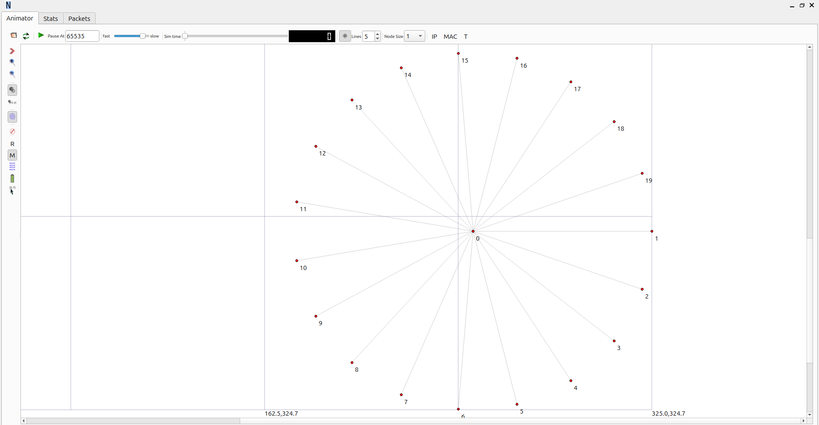

2) Hybrid topology:

Creating a file named hybrid.cc and saving the c code in tht

#include "ns3/core-module.h"
#include "ns3/network-module.h"
#include "ns3/internet-module.h"
#include "ns3/point-to-point-module.h"
#include "ns3/csma-module.h"
#include "ns3/netanim-module.h"
#include <cmath> // Needed for circular layouts
using namespace ns3;
int main (int argc, char *argv[])
{
// --- 1. DEFINE NODE COUNTS (Total = 40) ---
uint32_t nStarSpokes = 13; // +1 Hub = 14 Star Nodes
uint32_t nBusNodes = 13;
uint32_t nRingNodes = 13;
// --- 2. CREATE NODES ---
NodeContainer starHub; starHub.Create (1);
NodeContainer starSpokes; starSpokes.Create (nStarSpokes);
NodeContainer busNodes; busNodes.Create (nBusNodes);
NodeContainer ringNodes; ringNodes.Create (nRingNodes);
// --- 3. CONFIGURE HELPERS ---
PointToPointHelper p2p;
p2p.SetDeviceAttribute ("DataRate", StringValue ("5Mbps"));
p2p.SetChannelAttribute ("Delay", StringValue ("2ms"));
CsmaHelper csma;
csma.SetChannelAttribute ("DataRate", StringValue ("100Mbps"));
csma.SetChannelAttribute ("Delay", StringValue ("6560ns"));

InternetStackHelper stack;
stack.Install (starHub);
stack.Install (starSpokes);
stack.Install (busNodes);
stack.Install (ringNodes);

Ipv4AddressHelper address;

// --- 4. BUILD STAR TOPOLOGY (Left) ---
// Connect Hub to all Spokes
for (uint32_t i = 0; i < nStarSpokes; ++i) {
NetDeviceContainer link = p2p.Install (starHub.Get (0), starSpokes.Get (i));
std::ostringstream subnet;
subnet << "10.1." << (i + 1) << ".0";
address.SetBase (subnet.str ().c_str (), "255.255.255.0");
address.Assign (link);
}

// --- 5. BUILD BUS TOPOLOGY (Bottom Center) ---
NetDeviceContainer busDevices = csma.Install (busNodes);
address.SetBase ("10.2.1.0", "255.255.255.0");
address.Assign (busDevices);

// --- 6. BUILD RING TOPOLOGY (Right) ---
// Connect i to i+1
for (uint32_t i = 0; i < nRingNodes; ++i) {
NetDeviceContainer link = p2p.Install (ringNodes.Get (i), ringNodes.Get ((i + 1) % nRingNodes));
std::ostringstream subnet;
subnet << "10.3." << (i + 1) << ".0";
address.SetBase (subnet.str ().c_str (), "255.255.255.0");
address.Assign (link);
}

// --- 7. BRIDGE THE TOPOLOGIES ---
// Bridge Star (Hub) -> Bus (Node 0)
NetDeviceContainer bridge1 = p2p.Install (starHub.Get (0), busNodes.Get (0));
address.SetBase ("10.4.1.0", "255.255.255.0");
address.Assign (bridge1);

// Bridge Bus (Last Node) -> Ring (Node 0)
NetDeviceContainer bridge2 = p2p.Install (busNodes.Get (nBusNodes - 1), ringNodes.Get (0));
address.SetBase ("10.4.2.0", "255.255.255.0");
address.Assign (bridge2);

// --- 8. VISUALIZATION (THE IMPORTANT PART) ---
AnimationInterface anim ("hybrid_40.xml");

// A. STAR LAYOUT (Left Side)
// Hub at (30, 40)
anim.SetConstantPosition (starHub.Get (0), 30.0, 40.0);
for (uint32_t i = 0; i < nStarSpokes; ++i) {
double angle = 2 * 3.14159 * i / nStarSpokes;
anim.SetConstantPosition (starSpokes.Get (i),
30.0 + 20.0 * cos (angle), // Radius 20
40.0 + 20.0 * sin (angle));
}
// B. BUS LAYOUT (Bottom Line)
// Stretches from X=10 to X=140 at Y=80
for (uint32_t i = 0; i < nBusNodes; ++i) {
anim.SetConstantPosition (busNodes.Get (i), 10.0 + (i * 10.0), 80.0);
}
// C. RING LAYOUT (Right Side)
// Center at (120, 40)
for (uint32_t i = 0; i < nRingNodes; ++i) {
double angle = 2 * 3.14159 * i / nRingNodes;
anim.SetConstantPosition (ringNodes.Get (i),
120.0 + 20.0 * cos (angle), // Radius 20
40.0 + 20.0 * sin (angle));
}
Simulator::Run ();
Simulator::Destroy ();
return 0;
}

Executing it through command “./ns3 run scratch/hybrid “ creates a file named hybrid.xml
Output:

Displaying output through netanim:
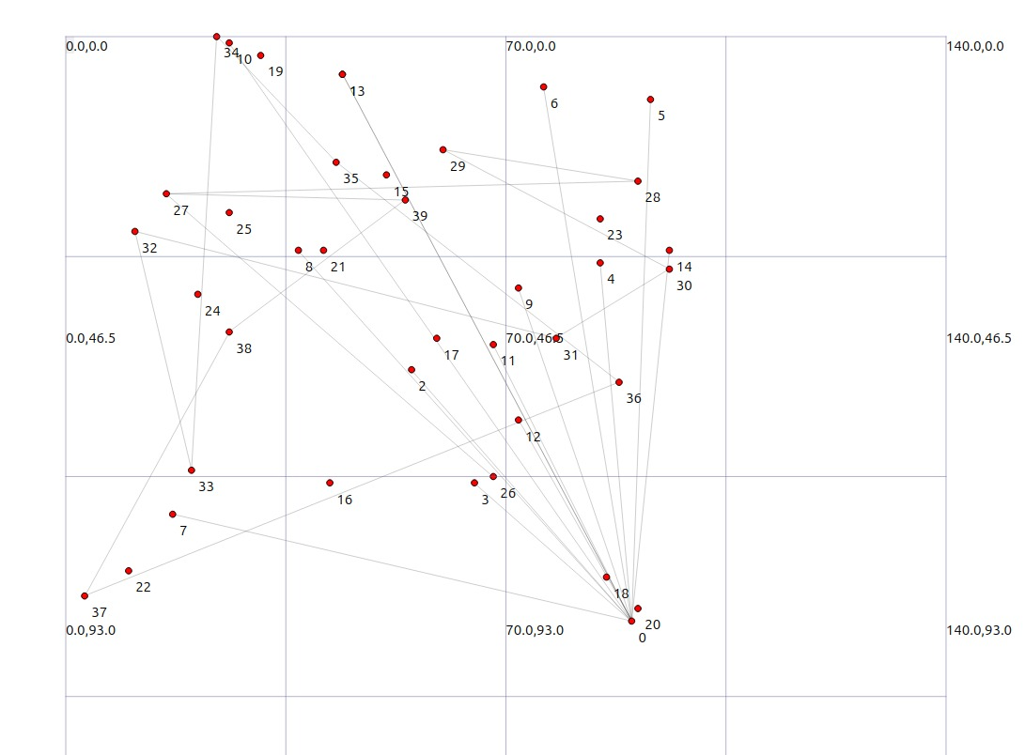

3) Ring topology:

Creating a file named ring.cc and saving the c code in tht

#include "ns3/core-module.h"
#include "ns3/network-module.h"
#include "ns3/internet-module.h"
#include "ns3/point-to-point-module.h"
#include "ns3/netanim-module.h"
#include "ns3/mobility-module.h"
using namespace ns3;
int main (int argc, char *argv[])
{
uint32_t nNodes = 20;
NodeContainer nodes;
nodes.Create (nNodes);
// 1. Create Links (Point-to-Point)
PointToPointHelper p2p;
p2p.SetDeviceAttribute ("DataRate", StringValue ("5Mbps"));
p2p.SetChannelAttribute ("Delay", StringValue ("2ms"));
InternetStackHelper internet;
internet.Install (nodes);
Ipv4AddressHelper address;
// 2. Loop to connect Ring
for (uint32_t i = 0; i < nNodes; ++i)
{
// Connect Node i to Node i+1 (wrapping around to 0 at the end)
NetDeviceContainer link = p2p.Install (nodes.Get(i), nodes.Get((i+1) % nNodes));
// Assign unique subnet to each link (10.1.1.0, 10.1.2.0, etc.)
std::ostringstream subnet;
subnet << "10.1." << (i + 1) << ".0";
address.SetBase (subnet.str ().c_str (), "255.255.255.0");
address.Assign (link);
}
// 3. FIX: Install Mobility
MobilityHelper mobility;
mobility.SetMobilityModel ("ns3::ConstantPositionMobilityModel");
mobility.Install (nodes);
// 4. Setup Animation (Circular Layout)
AnimationInterface anim ("ring.xml");
double centerX = 50.0;
double centerY = 50.0;
double radius = 30.0;
for (uint32_t i = 0; i < nNodes; ++i)
{
// Math to place dots in a circle
double theta = 2.0 * 3.14159 * i / nNodes;
double x = centerX + radius * cos (theta);
double y = centerY + radius * sin (theta);
anim.SetConstantPosition (nodes.Get (i), x, y);
}
Simulator::Run ();
Simulator::Destroy ();
return 0;
}

Executing it through command “./ns3 run scratch/ring “ creates a file named ring.xml

Output:

Displaying output through netanim:

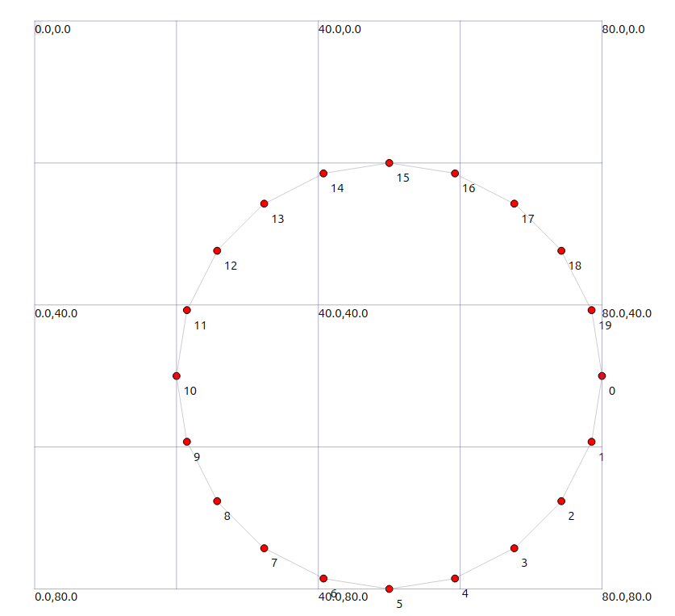

4) Grid topology:

Creating a file named grid.cc and saving the c code in tht
#include "ns3/core-module.h"
#include "ns3/network-module.h"
#include "ns3/internet-module.h"
#include "ns3/point-to-point-module.h"
#include "ns3/point-to-point-layout-module.h"
#include "ns3/netanim-module.h"
using namespace ns3;
int main (int argc, char *argv[])
{
// 1. Setup the Grid Helper (5x4)
PointToPointHelper p2p;
p2p.SetDeviceAttribute ("DataRate", StringValue ("5Mbps"));
p2p.SetChannelAttribute ("Delay", StringValue ("2ms"));
// This automatically connects the nodes in a grid pattern for you
PointToPointGridHelper grid (5, 4, p2p);
// 2. Install Internet Stack
InternetStackHelper internet;
grid.InstallStack (internet);
// 3. Assign IP Addresses
grid.AssignIpv4Addresses (Ipv4AddressHelper ("10.1.1.0", "255.255.255.0"),
Ipv4AddressHelper ("10.2.1.0", "255.255.255.0"));
// 4. Setup Animation
AnimationInterface anim ("grid.xml");
for (uint32_t r = 0; r < 5; ++r)
{
for (uint32_t c = 0; c < 4; ++c)
{
// Get the node at this specific grid spot
Ptr<Node> node = grid.GetNode (r, c);
// Set its position: X = column * spacing, Y = row * spacing
anim.SetConstantPosition (node, c * 20.0, r * 20.0);
}
}

Simulator::Run ();
Simulator::Destroy ();
return 0;
}

Executing it through command “./ns3 run scratch/grid “ creates a file named grid.xml
Output:

Displaying output through netanim:

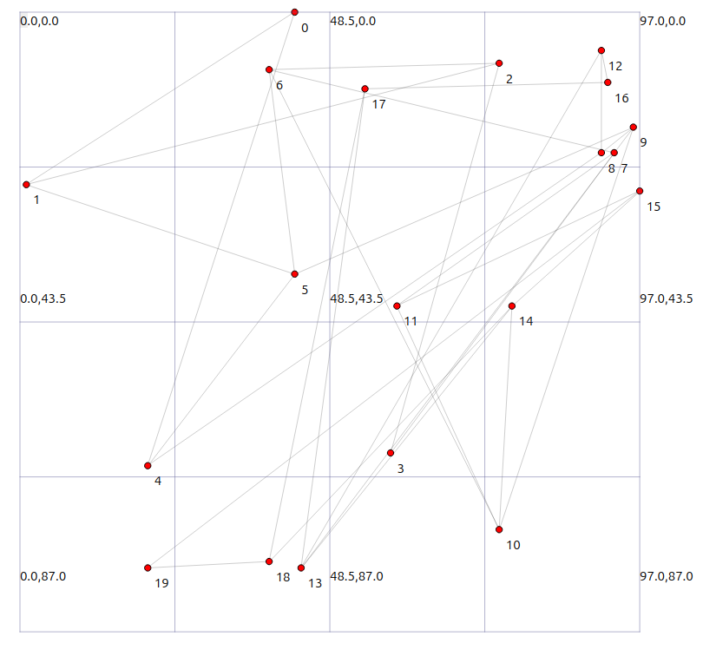

5) Mesh topology:

Creating a file named mesh.cc and saving the c code in tht

#include "ns3/core-module.h"
#include "ns3/network-module.h"
#include "ns3/internet-module.h"
#include "ns3/point-to-point-module.h"
#include "ns3/netanim-module.h"
#include <sstream> // REQUIRED for the subnet text generation
#include <cmath> // REQUIRED for sin/cos math

using namespace ns3;

int main (int argc, char *argv[])
{
// 1. Create 15 Nodes
uint32_t nNodes = 15;
NodeContainer nodes;
nodes.Create (nNodes);

// 2. Setup Link Helper
PointToPointHelper p2p;
p2p.SetDeviceAttribute ("DataRate", StringValue ("5Mbps"));
p2p.SetChannelAttribute ("Delay", StringValue ("2ms"));

// 3. Install Internet Stack
InternetStackHelper internet;
internet.Install (nodes);

// 4. Connect Every Node to Every Other Node
Ipv4AddressHelper address;
int linkCount = 1;

for (uint32_t i = 0; i < nNodes; ++i)
{
for (uint32_t j = i + 1; j < nNodes; ++j)
{
// Install link between Node i and Node j
NetDeviceContainer link = p2p.Install (nodes.Get (i), nodes.Get (j));

// Create a unique subnet for this specific link (e.g., 10.1.1.0, 10.2.1.0)
std::ostringstream subnet;
subnet << "10." << linkCount << ".1.0";

address.SetBase (subnet.str ().c_str (), "255.255.255.0");
address.Assign (link);

linkCount++;
}
}

// 5. Setup Animation
AnimationInterface anim ("mesh.xml");

// 6. Set Node Positions (Circle) so they show up in NetAnim
double centerX = 50.0;
double centerY = 50.0;
double radius = 40.0;

for (uint32_t i = 0; i < nNodes; ++i)
{
double theta = 2.0 * 3.14159 * i / nNodes;
double x = centerX + radius * cos (theta);
double y = centerY + radius * sin (theta);

anim.SetConstantPosition (nodes.Get (i), x, y);
}

// 7. Run
Simulator::Run ();
Simulator::Destroy ();
return 0;
}

Executing it through command “./ns3 run scratch/mesh “ creates a file named mesh.xml
Output:

Displaying output through netanim:

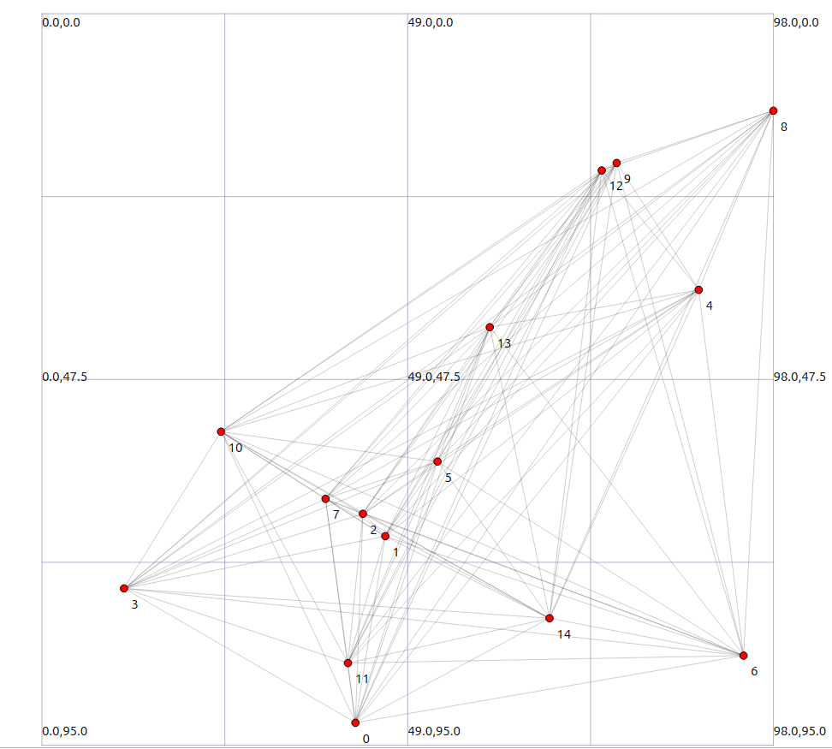

GitHub repo :
https://github.com/Adhithya-cr7/ns-3-network-topologies
Referred From:
